DBMS LAB EXPREMENTS
DDL Commands :- Create, Alter,Drop
Out put:
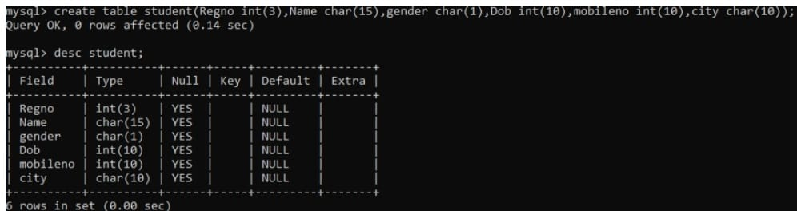
1)
2.
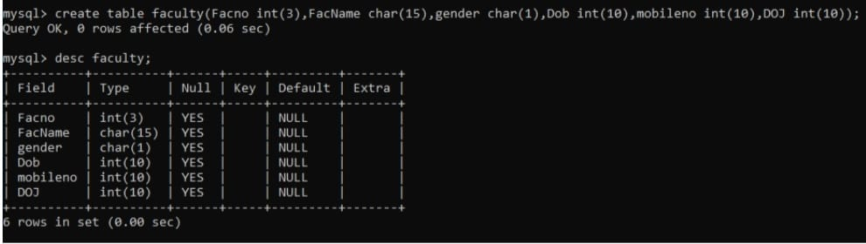
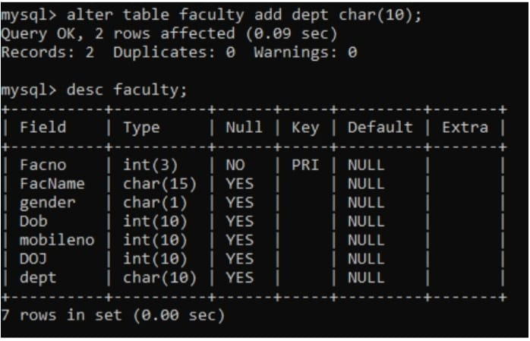
3.

4.
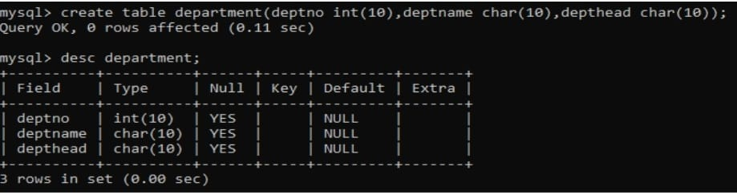
5.
